**JOHNNY LOUIS**

**Computing As a Service - Creating a Rule for a Non-Relational Database**

**1: Create the DynamoDB table**

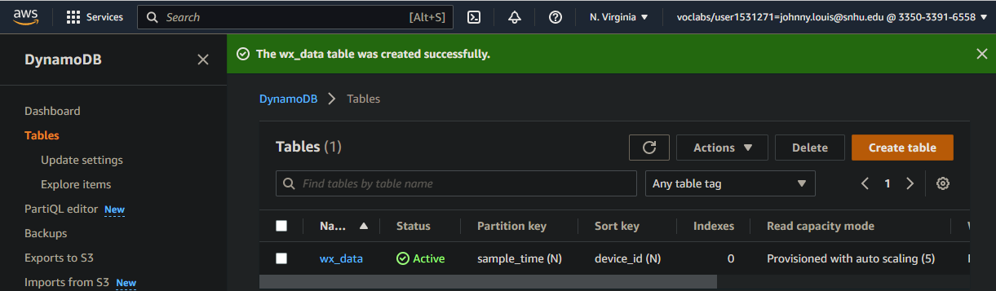

**2: Create an AWS Internet of Things (IoT) rule to send data to the DynamoDB table**

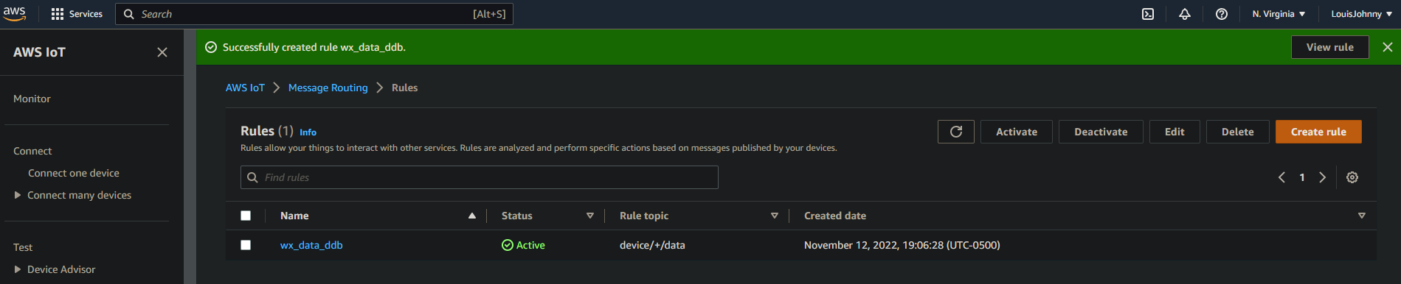

**3: MQTT test Rule client**

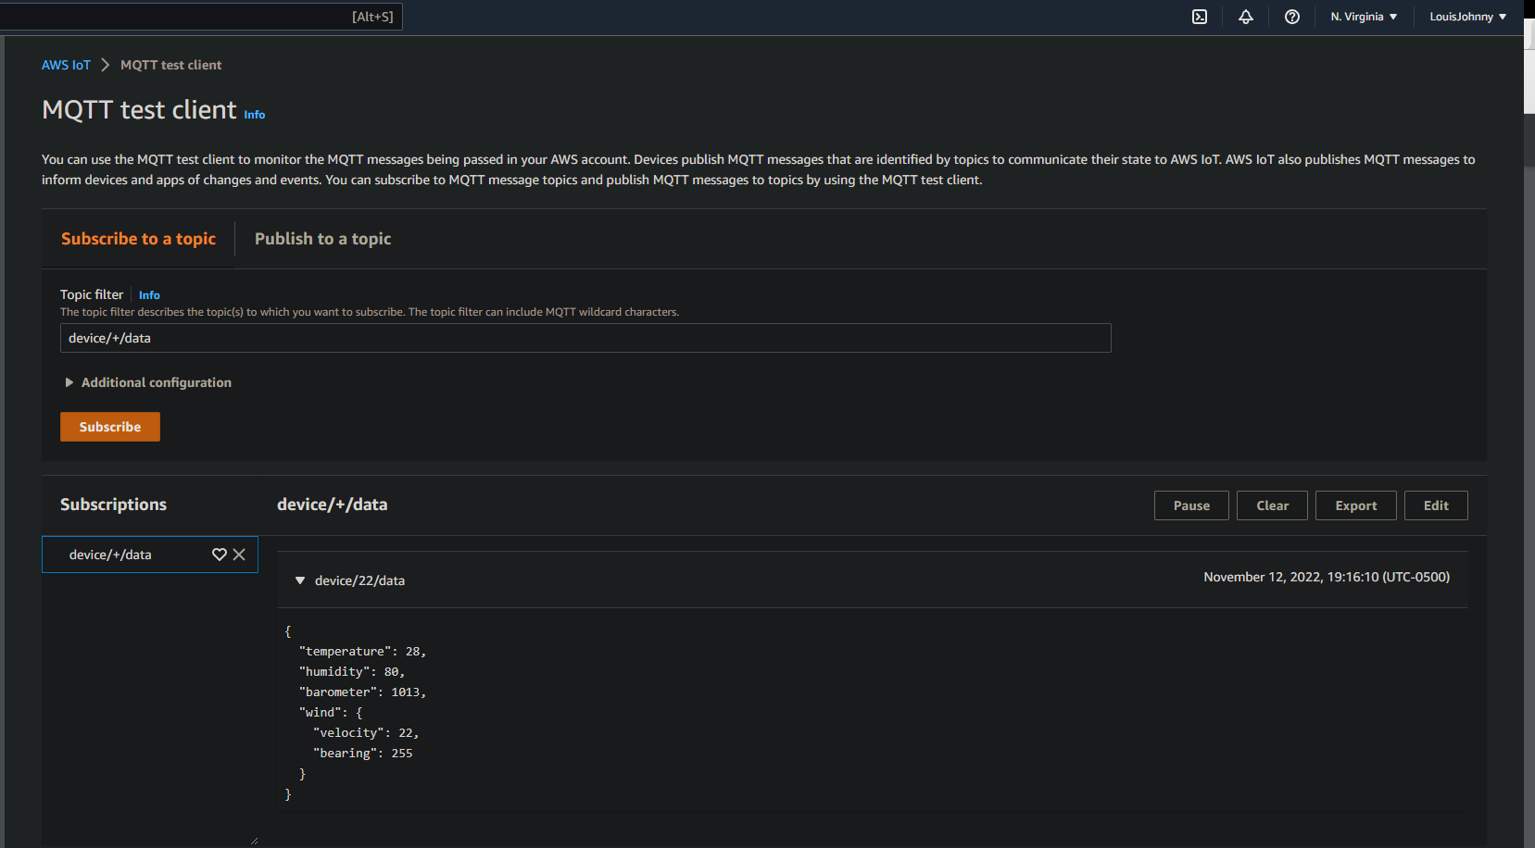

**4: View the device_data**

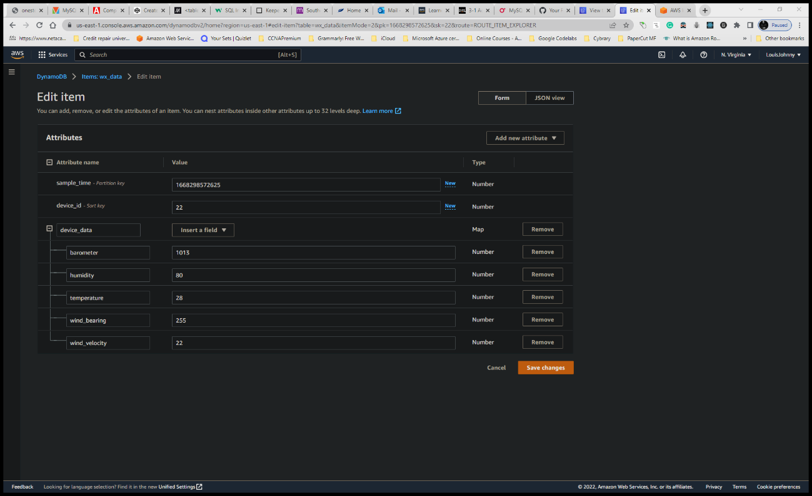

**Reflection:**

* What is an appropriate business scenario where a key-value document-based database like DynamoDB would be used?

The hands-on lab for this week shows me how quickly and how important DynamoDB is. DynamoDB will be useful for any organization that only has a small budget for running its data in the cloud. Amazon DynamoDB is the go-to for a company that needs to operate directly on AWS. It's very easy to set up and also very secure in terms of IAM setup. You won’t need to wait for a long period of time because the DynamoDB connection can be established in less time than you think. It has a very high performance with a low cost compared to SQL and other databases out there. The only downside of using DynamoDB is that it only takes three data types keys, string, numbers, and binary. “Furthermore, DynamoDB uses a throughput model for pricing and data processing by default. With this model, you estimate your read/write capacity needs before the service can appropriate the resources. In cases where you don’t really know your expected read/write volumes, you might under- or overestimate your needs, which can lead to batch-processing failures. Of course, you can use the on-demand pricing model to work around this, and DynamoDB will automatically accommodate your workloads as they ramp up or down. But that comes with the risk of bill spikes if your project’s traffic ends up higher than initially expected.”

* What’s a best practice for isolating frequently used items?

The best practice for isolation frequently used items will be to keep the traffic runs as low as possible and to make sure that the operations are going smoothly. If for some reasons that items are not properly isolating, the system can encounter a performance issue and security. This is best known for data throttling says (Amazon.com).

* When should you use a DynamoDB Rule compared to other rules, such as Lambda Action and SNS?

The best practice for the isolation of frequently used items will be to keep the traffic runs as low as possible and to make sure that the operations are going smoothly. If for some reason items are not properly isolated, the system can encounter performance issues and security. This is best known for data throttling says (Amazon.com). Amazon DynamoDB Rules mostly worked with Lambda rules functions, however, rules defined in DynamoDB will provide better scalability for your organization. When rules are created as well as defined, the is an SNS message that is sent to the client immediately. AWS IoT is a very great tool added to Amazon Web Services. It allows you to connect IoT devices with AWS services. AWS IoT works in all types of organizations, including any organization that needs or uses AWS as the cloud platform. “The DynamoDB rule is written to send messages to the DynamoDB table using the API of dynamo DB. DynamoDBv2 sends messages to multiple tables in the database of dynamo DB” (studocu.com.). The rule for Lambda invokes a lambda function with message data as input. SNS rule published a message on Amazon notification services using push notification.